Supplementary Tables

Supplementary Table S1. Meteorological data for the two growing seasons

Sr. No. | Month/Year | Rainfall (mm) | Ave. Temperature (ºC)
Sr. No. | Month/Year | Rainfall (mm) | Min. | Max.
1 | July 2024 | 115 | 26 | 38
2 | August 2024 | 169 | 23 | 35
3 | September 2024 | 180 | 23 | 34
4. | October 2024 | 49 | 18 | 31
5. | November 2024 | 25 | 10 | 24
6. | December 2024 | 0 | 03 | 17
7. | January 2025 | 0 | 03 | 16
8. | February 2025 | 26 | 10 | 20
9. | March 2025 | 41 | 10 | 24
10. | April 2025 | 13 | 18 | 32
11. | May 2025 | 153 | 20 | 30
12. | June 2025 | 71 | 30 | 35
13. | July 2025 | 374 | 27 | 31
14. | August 2025 | 265 | 27 | 33
15. | September 2025 | 0 | 26 | 34
16. | October 2025 | 18 | 21 | 29
17. | November 2025 | 2 | 16 | 22
18. | December 2025 | 2 | 8 | 21

Supplementary Table S2. Complete list of BLUP-adjusted means for all 103 genotypes at both anthesis and maturity across 2024 and 2025.
Year | 2024 |  |  |  | 2025
Genotype | Adju.mean | SE | lower.CL | upper.CL | Adju. mean | SE | lower.CL | upper.CL
Pak - 47 | 17.50 | 0.86 | 15.75 | 19.25 | 18.50 | 0.86 | 16.75 | 20.25
SGD - 011 - 2 | 16.00 | 0.86 | 14.25 | 17.75 | 18.00 | 0.86 | 16.25 | 19.75
S-2011 | 13.00 | 0.86 | 11.25 | 14.75 | 18.00 | 0.86 | 16.25 | 19.75
Sweet Sorghm | 16.50 | 0.86 | 14.75 | 18.25 | 17.50 | 0.86 | 15.75 | 19.25
PARC - 2009 | 16.50 | 0.86 | 14.75 | 18.25 | 17.00 | 0.86 | 15.25 | 18.75
L - 56 | 15.50 | 0.86 | 13.75 | 17.25 | 17.00 | 0.86 | 15.25 | 18.75
Asil | 16.50 | 0.86 | 14.75 | 18.25 | 16.50 | 0.86 | 14.75 | 18.25
I-08 | 15.50 | 0.86 | 13.75 | 17.25 | 16.50 | 0.86 | 14.75 | 18.25
SC 56 - 14 | 14.00 | 0.86 | 12.25 | 15.75 | 16.50 | 0.86 | 14.75 | 18.25
SC 56/ SC 110 STAY Green | 13.00 | 0.86 | 11.25 | 14.75 | 16.50 | 0.86 | 14.75 | 18.25
GP - 15 | 18.00 | 0.86 | 16.25 | 19.75 | 16.00 | 0.86 | 14.25 | 17.75
F - 902 | 17.00 | 0.86 | 15.25 | 18.75 | 16.00 | 0.86 | 14.25 | 17.75
Kohe Suleman | 17.00 | 0.86 | 15.25 | 18.75 | 16.00 | 0.86 | 14.25 | 17.75
PVK - 801 | 16.50 | 0.86 | 14.75 | 18.25 | 16.00 | 0.86 | 14.25 | 17.75
F - 9806 | 15.00 | 0.86 | 13.25 | 16.75 | 16.00 | 0.86 | 14.25 | 17.75
F - 901 | 13.50 | 0.86 | 11.75 | 15.25 | 16.00 | 0.86 | 14.25 | 17.75
FRI - 07 | 12.50 | 0.86 | 10.75 | 14.25 | 16.00 | 0.86 | 14.25 | 17.75
A-4 | 10.50 | 0.86 | 8.75 | 12.25 | 16.00 | 0.86 | 14.25 | 17.75
JS - 100 | 15.50 | 0.86 | 13.75 | 17.25 | 15.50 | 0.86 | 13.75 | 17.25
IS 12676 C | 7.00 | 0.86 | 5.25 | 8.75 | 15.50 | 0.86 | 13.75 | 17.25
FJSS- 03 | 17.50 | 0.86 | 15.75 | 19.25 | 15.00 | 0.86 | 13.25 | 16.75
F - 904 | 16.50 | 0.86 | 14.75 | 18.25 | 15.00 | 0.86 | 13.25 | 16.75
JS - 02 | 15.00 | 0.86 | 13.25 | 16.75 | 15.00 | 0.86 | 13.25 | 16.75
Nili bar | 14.00 | 0.86 | 12.25 | 15.75 | 15.00 | 0.86 | 13.25 | 16.75
F - 903 | 13.50 | 0.86 | 11.75 | 15.25 | 15.00 | 0.86 | 13.25 | 16.75
Pulharam | 13.50 | 0.86 | 11.75 | 15.25 | 15.00 | 0.86 | 13.25 | 16.75
IS - 1141 C | 11.50 | 0.86 | 9.75 | 13.25 | 15.00 | 0.86 | 13.25 | 16.75
F - 2007 | 16.50 | 0.86 | 14.75 | 18.25 | 14.50 | 0.86 | 12.75 | 16.25
FJSS- 02 | 16.00 | 0.86 | 14.25 | 17.75 | 14.50 | 0.86 | 12.75 | 16.25
GP- 19 | 16.00 | 0.86 | 14.25 | 17.75 | 14.50 | 0.86 | 12.75 | 16.25
SC - 1338 C | 13.50 | 0.86 | 11.75 | 15.25 | 14.50 | 0.86 | 12.75 | 16.25
F - 906 | 12.00 | 0.86 | 10.25 | 13.75 | 14.50 | 0.86 | 12.75 | 16.25
I-06 | 11.50 | 0.86 | 9.75 | 13.25 | 14.50 | 0.86 | 12.75 | 16.25
F - 02 - 10 | 16.00 | 0.86 | 14.25 | 17.75 | 14.00 | 0.86 | 12.25 | 15.75
Saiyaari | 13.50 | 0.86 | 11.75 | 15.25 | 14.00 | 0.86 | 12.25 | 15.75
FM - 48 | 13.00 | 0.86 | 11.25 | 14.75 | 14.00 | 0.86 | 12.25 | 15.75
IS 17208 C | 13.00 | 0.86 | 11.25 | 14.75 | 14.00 | 0.86 | 12.25 | 15.75
F - 708 | 12.00 | 0.86 | 10.25 | 13.75 | 14.00 | 0.86 | 12.25 | 15.75
No - 5017 | 11.50 | 0.86 | 9.75 | 13.25 | 14.00 | 0.86 | 12.25 | 15.75
Ausaf | 13.00 | 0.36 | 12.27 | 13.73 | 13.81 | 0.36 | 13.08 | 14.54
Tandi | 15.50 | 0.86 | 13.75 | 17.25 | 13.50 | 0.86 | 11.75 | 15.25
Higari | 15.00 | 0.86 | 13.25 | 16.75 | 13.50 | 0.86 | 11.75 | 15.25
B - 599 | 14.50 | 0.86 | 12.75 | 16.25 | 13.50 | 0.86 | 11.75 | 15.25
JS-2007 | 14.00 | 0.86 | 12.25 | 15.75 | 13.50 | 0.86 | 11.75 | 15.25
F - 03 - 10 | 16.00 | 0.86 | 14.25 | 17.75 | 13.00 | 0.86 | 11.25 | 14.75
Hock | 16.00 | 0.86 | 14.25 | 17.75 | 13.00 | 0.86 | 11.25 | 14.75
S - 9901 | 15.00 | 0.86 | 13.25 | 16.75 | 13.00 | 0.86 | 11.25 | 14.75
IS 12680 | 14.00 | 0.86 | 12.25 | 15.75 | 13.00 | 0.86 | 11.25 | 14.75
Super | 13.50 | 0.86 | 11.75 | 15.25 | 13.00 | 0.86 | 11.25 | 14.75
India | 13.00 | 0.86 | 11.25 | 14.75 | 13.00 | 0.86 | 11.25 | 14.75
IS 1477 C | 13.00 | 0.86 | 11.25 | 14.75 | 13.00 | 0.86 | 11.25 | 14.75
JS - 263 | 15.00 | 0.86 | 13.25 | 16.75 | 12.50 | 0.86 | 10.75 | 14.25
No - 3448 | 14.50 | 0.86 | 12.75 | 16.25 | 12.50 | 0.86 | 10.75 | 14.25
I-12 | 14.00 | 0.86 | 12.25 | 15.75 | 12.50 | 0.86 | 10.75 | 14.25
No. 1749 | 14.00 | 0.86 | 12.25 | 15.75 | 12.50 | 0.86 | 10.75 | 14.25
R - 9188 | 12.00 | 0.86 | 10.25 | 13.75 | 12.50 | 0.86 | 10.75 | 14.25
IS 12666 C | 11.00 | 0.86 | 9.25 | 12.75 | 12.50 | 0.86 | 10.75 | 14.25
SL - 14 | 17.00 | 0.86 | 15.25 | 18.75 | 12.00 | 0.86 | 10.25 | 13.75
Sandal Bar | 16.00 | 0.86 | 14.25 | 17.75 | 12.00 | 0.86 | 10.25 | 13.75
BJ - 1914 | 14.50 | 0.86 | 12.75 | 16.25 | 12.00 | 0.86 | 10.25 | 13.75
BJ - 169 | 14.00 | 0.86 | 12.25 | 15.75 | 12.00 | 0.86 | 10.25 | 13.75
SL - 18 | 16.50 | 0.86 | 14.75 | 18.25 | 11.50 | 0.86 | 9.75 | 13.25
SC56- 6 | 16.00 | 0.86 | 14.25 | 17.75 | 11.50 | 0.86 | 9.75 | 13.25
Sild Marhar | 15.50 | 0.86 | 13.75 | 17.25 | 11.50 | 0.86 | 9.75 | 13.25
Sukkhur | 15.00 | 0.86 | 13.25 | 16.75 | 11.50 | 0.86 | 9.75 | 13.25
IS 12576 C | 14.50 | 0.86 | 12.75 | 16.25 | 11.50 | 0.86 | 9.75 | 13.25
F - 01- 10 | 14.00 | 0.86 | 12.25 | 15.75 | 11.50 | 0.86 | 9.75 | 13.25
GP- 37 | 13.00 | 0.86 | 11.25 | 14.75 | 11.50 | 0.86 | 9.75 | 13.25
MSM - 04 | 15.50 | 0.86 | 13.75 | 17.25 | 11.00 | 0.86 | 9.25 | 12.75
IS 12632 C | 14.50 | 0.86 | 12.75 | 16.25 | 11.00 | 0.86 | 9.25 | 12.75
I-05 | 12.50 | 0.86 | 10.75 | 14.25 | 11.00 | 0.86 | 9.25 | 12.75
IS 1366 C | 10.50 | 0.86 | 8.75 | 12.25 | 11.00 | 0.86 | 9.25 | 12.75
PARC- SS -2 | 14.50 | 0.86 | 12.75 | 16.25 | 10.50 | 0.86 | 8.75 | 12.25
9946 | 14.00 | 0.86 | 12.25 | 15.75 | 10.50 | 0.86 | 8.75 | 12.25
JS-263 | 12.50 | 0.86 | 10.75 | 14.25 | 10.50 | 0.86 | 8.75 | 12.25
IS 6213 C | 16.50 | 0.86 | 14.75 | 18.25 | 10.00 | 0.86 | 8.25 | 11.75
1542 | 11.00 | 0.86 | 9.25 | 12.75 | 10.00 | 0.86 | 8.25 | 11.75
S - 149 | 17.50 | 0.86 | 15.75 | 19.25 | 9.50 | 0.86 | 7.75 | 11.25
K - 94 | 16.00 | 0.86 | 14.25 | 17.75 | 9.50 | 0.86 | 7.75 | 11.25
Soro Karthahu | 15.00 | 0.86 | 13.25 | 16.75 | 9.50 | 0.86 | 7.75 | 11.25
SC - 1215 | 13.50 | 0.86 | 11.75 | 15.25 | 9.50 | 0.86 | 7.75 | 11.25
F - 2008 | 13.00 | 0.86 | 11.25 | 14.75 | 9.50 | 0.86 | 7.75 | 11.25
No. 86 | 13.00 | 0.86 | 11.25 | 14.75 | 9.50 | 0.86 | 7.75 | 11.25
No. 394 | 9.50 | 0.86 | 7.75 | 11.25 | 9.50 | 0.86 | 7.75 | 11.25
Pak sorghum | 8.87 | 0.36 | 8.14 | 9.60 | 9.11 | 0.36 | 8.38 | 9.84
P - 05 - 10 | 18.50 | 0.86 | 16.75 | 20.25 | 9.00 | 0.86 | 7.25 | 10.75
IS 7229 C | 17.00 | 0.86 | 15.25 | 18.75 | 9.00 | 0.86 | 7.25 | 10.75
K - 91 | 17.00 | 0.86 | 15.25 | 18.75 | 9.00 | 0.86 | 7.25 | 10.75
BMR- 14 | 15.00 | 0.86 | 13.25 | 16.75 | 9.00 | 0.86 | 7.25 | 10.75
IS 2904 C | 13.00 | 0.86 | 11.25 | 14.75 | 9.00 | 0.86 | 7.25 | 10.75
IS 83370 | 9.50 | 0.86 | 7.75 | 11.25 | 9.00 | 0.86 | 7.25 | 10.75
IS - 10281 C | 8.00 | 0.86 | 6.25 | 9.75 | 9.00 | 0.86 | 7.25 | 10.75
Chakwal Sorghum | 10.06 | 0.36 | 9.33 | 10.79 | 8.80 | 0.36 | 8.07 | 9.53
Kanori local | 14.00 | 0.86 | 12.25 | 15.75 | 8.50 | 0.86 | 6.75 | 10.25
S - 167 | 9.50 | 0.86 | 7.75 | 11.25 | 8.50 | 0.86 | 6.75 | 10.25
No. 1518 | 17.00 | 0.86 | 15.25 | 18.75 | 8.00 | 0.86 | 6.25 | 9.75
I-13 | 15.00 | 0.86 | 13.25 | 16.75 | 7.50 | 0.86 | 5.75 | 9.25
IS 2177 C | 15.50 | 0.86 | 13.75 | 17.25 | 7.00 | 0.86 | 5.25 | 8.75
SC - 1423 - 2BK | 12.00 | 0.86 | 10.25 | 13.75 | 6.50 | 0.86 | 4.75 | 8.25
Jable | 16.00 | 0.86 | 14.25 | 17.75 | 6.00 | 0.86 | 4.25 | 7.75
IS 7344 C | 9.50 | 0.86 | 7.75 | 11.25 | 4.50 | 0.86 | 2.75 | 6.25
IS 12550 C | 4.00 | 0.86 | 2.25 | 5.75 | 4.50 | 0.86 | 2.75 | 6.25
S - 58 | 15.50 | 0.86 | 13.75 | 17.25 | 3.50 | 0.86 | 1.75 | 5.25
Supplementary Table S3. Full WAASB scores and rankings for every genotype in the study.
Genotype | Mean_Brix | WAASB | Rank_Mean | Rank_Stability | Overall_Rank
Pak - 47 | 18.00 | 0.59 | 1 | 83 | 36
GP - 15 | 17.00 | 0.20 | 3 | 15 | 3
Sweet Sorghm | 17.00 | 0.48 | 3 | 70 | 27
SGD - 011 - 2 | 17.00 | 0.56 | 3 | 80 | 34
PARC - 2009 | 16.75 | 0.41 | 5 | 58 | 19
F - 902 | 16.50 | 0.05 | 7 | 1 | 1
Kohe Suleman | 16.50 | 0.35 | 7 | 46 | 18
Asil | 16.50 | 0.55 | 7 | 77 | 36
FJSS- 03 | 16.25 | 0.11 | 10 | 2 | 2
PVK - 801 | 16.25 | 0.55 | 10 | 78 | 39
L - 56 | 16.25 | 0.79 | 10 | 96 | 55
I-08 | 16.00 | 0.30 | 12 | 32 | 12
F - 904 | 15.75 | 0.29 | 13 | 29 | 10
F - 2007 | 15.50 | 0.11 | 16 | 3 | 4
JS - 100 | 15.50 | 0.22 | 16 | 17 | 6
F - 9806 | 15.50 | 0.32 | 16 | 36 | 16
S-2011 | 15.50 | 0.82 | 16 | 98 | 60
FJSS- 02 | 15.25 | 0.24 | 19 | 21 | 8
GP- 19 | 15.25 | 0.30 | 19 | 31 | 14
SC 56 - 14 | 15.25 | 0.53 | 19 | 76 | 47
F - 02 - 10 | 15.00 | 0.12 | 22 | 4 | 5
JS - 02 | 15.00 | 0.37 | 22 | 48 | 24
F - 901 | 14.75 | 0.34 | 24 | 44 | 22
SC 56/ SC 110 STAY GREEN | 14.75 | 0.67 | 24 | 92 | 63
Hock | 14.50 | 0.17 | 27 | 10 | 7
F - 03 - 10 | 14.50 | 0.33 | 27 | 40 | 21
Nili bar | 14.50 | 0.35 | 27 | 45 | 26
SL - 14 | 14.50 | 0.38 | 27 | 52 | 30
Tandi | 14.50 | 0.65 | 27 | 91 | 66
BJ - 1914 | 14.33 | 0.20 | 30 | 13 | 11
Higari | 14.25 | 0.17 | 33 | 8 | 9
F - 903 | 14.25 | 0.24 | 33 | 20 | 17
Pulharam | 14.25 | 0.39 | 33 | 56 | 41
FRI - 07 | 14.25 | 0.49 | 33 | 73 | 54
Sandal Bar | 14.00 | 0.33 | 37 | 41 | 28
S - 9901 | 14.00 | 0.37 | 37 | 49 | 37
SC - 1338 C | 14.00 | 0.39 | 37 | 55 | 44
SL - 18 | 14.00 | 0.41 | 37 | 60 | 49
B - 599 | 14.00 | 0.45 | 37 | 62 | 52
JS - 263 | 13.75 | 0.15 | 42 | 7 | 13
JS-2007 | 13.75 | 0.17 | 42 | 9 | 15
Saiyaari | 13.75 | 0.32 | 42 | 38 | 31
SC56- 6 | 13.75 | 0.50 | 42 | 74 | 64
P - 05 - 10 | 13.75 | 0.76 | 42 | 95 | 79
FM - 48 | 13.50 | 0.22 | 48 | 18 | 20
Sild Marhar | 13.50 | 0.30 | 48 | 34 | 32
IS 12680 | 13.50 | 0.33 | 48 | 42 | 42
No - 3448 | 13.50 | 0.33 | 48 | 43 | 43
IS 17208 C | 13.50 | 0.48 | 48 | 71 | 68
S - 149 | 13.50 | 0.57 | 48 | 81 | 74
Ausaf | 13.41 | 0.37 | 51 | 50 | 53
Sukkhur | 13.25 | 0.20 | 56 | 16 | 26
No. 1749 | 13.25 | 0.26 | 56 | 26 | 33
F - 906 | 13.25 | 0.39 | 56 | 57 | 59
MSM - 04 | 13.25 | 0.41 | 56 | 59 | 61
IS - 1141 C | 13.25 | 0.46 | 56 | 64 | 69
Super | 13.25 | 0.46 | 56 | 67 | 71
I-12 | 13.25 | 0.47 | 56 | 69 | 72
IS 6213 C | 13.25 | 0.49 | 56 | 72 | 73
A-4 | 13.25 | 0.63 | 56 | 87 | 81
India | 13.00 | 0.12 | 65 | 5 | 24
BJ - 169 | 13.00 | 0.20 | 65 | 14 | 29
IS 12576 C | 13.00 | 0.25 | 65 | 23 | 38
F - 708 | 13.00 | 0.30 | 65 | 30 | 46
I-06 | 13.00 | 0.39 | 65 | 54 | 68
IS 1477 C | 13.00 | 0.56 | 65 | 79 | 82
K - 91 | 13.00 | 0.60 | 65 | 85 | 85
IS 7229 C | 13.00 | 0.62 | 65 | 86 | 86
F - 01- 10 | 12.75 | 0.25 | 71 | 22 | 45
IS 12632 C | 12.75 | 0.26 | 71 | 25 | 48
No - 5017 | 12.75 | 0.58 | 71 | 82 | 88
K - 94 | 12.75 | 0.60 | 71 | 84 | 89
PARC- SS -2 | 12.50 | 0.25 | 74 | 24 | 50
No. 1518 | 12.50 | 0.64 | 74 | 89 | 90
9946 | 12.25 | 0.30 | 77 | 33 | 57
R - 9188 | 12.25 | 0.38 | 77 | 53 | 75
GP- 37 | 12.25 | 0.46 | 77 | 66 | 80
Soro Karthahu | 12.25 | 0.46 | 77 | 68 | 84
BMR- 14 | 12.00 | 0.89 | 79 | 99 | 96
I-05 | 11.75 | 0.31 | 81 | 35 | 63
IS 12666 C | 11.75 | 0.37 | 81 | 51 | 78
JS-263 | 11.50 | 0.14 | 83 | 6 | 41
SC - 1215 | 11.50 | 0.26 | 83 | 27 | 57
No. 86 | 11.25 | 0.18 | 87 | 12 | 51
I-13 | 11.25 | 0.63 | 87 | 88 | 94
IS 2177 C | 11.25 | 0.65 | 87 | 90 | 95
F - 2008 | 11.25 | 0.91 | 87 | 100 | 97
Kanori local | 11.25 | 0.97 | 87 | 101 | 99
IS 12676 C | 11.25 | 0.99 | 87 | 103 | 100
IS 2904 C | 11.00 | 0.42 | 91 | 61 | 87
Jable | 11.00 | 0.81 | 91 | 97 | 99
IS 1366 C | 10.75 | 0.32 | 92 | 39 | 77
1542 | 10.50 | 0.32 | 93 | 37 | 76
No. 394 | 9.50 | 0.28 | 95 | 28 | 70
S - 58 | 9.50 | 0.98 | 95 | 102 | 103
Chakwal Sorghum | 9.43 | 0.70 | 96 | 94 | 101
SC - 1423 - 2BK | 9.25 | 0.36 | 98 | 47 | 84
IS 83370 | 9.25 | 0.51 | 98 | 75 | 93
S - 167 | 9.00 | 0.23 | 99 | 19 | 66
Pak sorghum | 8.99 | 0.46 | 100 | 63 | 91
IS - 10281 C | 8.50 | 0.17 | 101 | 11 | 58
IS 7344 C | 7.00 | 0.46 | 102 | 65 | 92
IS 12550 C | 4.25 | 0.69 | 103 | 93 | 102

Supplementary Table S4. R² and significance of relationship of soil properties with brix% across growth stages

Soil Parameter | Growth Stage | Slope (β) | R2 | P-value | Significance
Potassium (K) | Maturity | 0.40 | 0.88 | 0.042 | *
 | Anthesis | 0.22 | 0.76 | 0.089 | ns
Organic Matter (OM) | Maturity | 16.0 | 0.91 | 0.031 | *
 | Anthesis | 8.80 | 0.65 | 0.120 | ns
Phosphorus (P) | Maturity | 0.51 | 0.84 | 0.048 | *
 | Anthesis | 0.30 | 0.72 | 0.095 | ns

Supplementary Figures

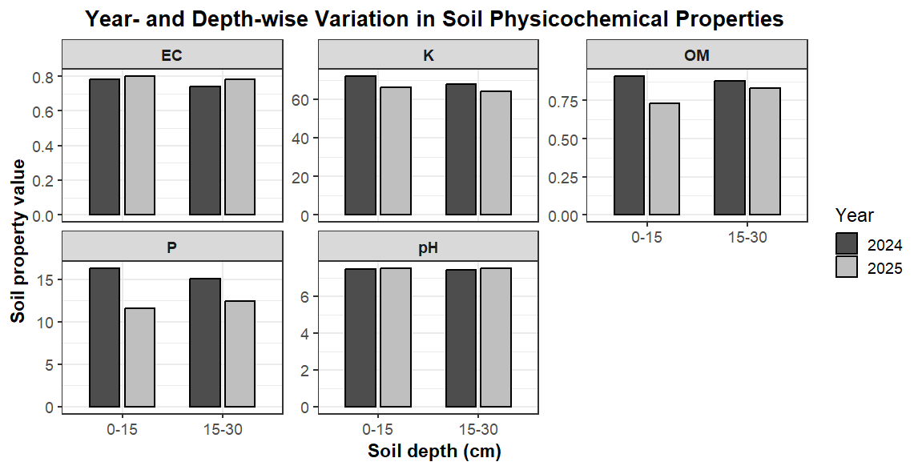
Supplementary Figure S1. Year- and depth-wise variation in soil physicochemical properties prior to sowing.

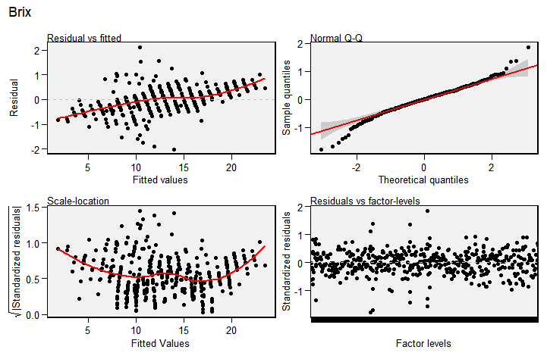
Supplementary Figure S2. Comprehensive set of residual diagnostic plots (Q-Q, Residuals vs. Fitted, Scale-Location) for model validation.

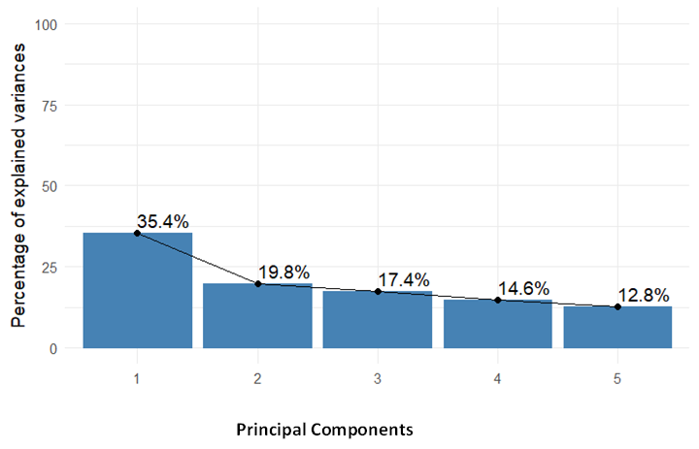

Supplementary Figure S3. Contribution of each Principal components to the total variation

